H.T No
Regulations:
A22

Sreenidhi Institute of Science and Technology
(An Autonomous Institution)
Code No: 9BC01 Date: 21-Aug-2023 (FN)

B.Tech I-Year II- Semester External Examination, Aug/Sept-2023 (Regular)
ENGINEERING GRAPHICS (CSE, IT, CS, AIML, DS and IOT)

Time: 3 Hours Max.Marks:60

Note: a) No additional answer sheets will be provided.
b) All sub-parts of a question must be answered at one place only, otherwise it will not be valued.
c) Missing data can be assumed suitably.
Bloom's Cognitive Levels of Learning (BCLL)

Remember | L1 | Apply | L3 | Evaluate | L5
Understand | L2 | Analyze | L4 | Create | L6

Part - A Max.Marks: 6x2=12

Answer all QUESTIONS, EACH QUESTION CARRIES 2 MARKS.

 |  | BCLL | CO(s) | Marks
1 | What are the applications of Hyperbola? | L2 | CO1 | [2M]
2 | What is the difference between First angle Projection and Third angle Projection? | L2 | CO2 | [2M]
3 | Define a Plane in Projection of Planes. | L1 | CO3 | [2M]
4 | What is the difference between a Prism and a Pyramid? | L2 | CO4 | [2M]
5 | What is isometric scale? | L1 | CO5 | [2M]
6 | What is the difference between isometric view and isometric protection? | L1 | CO6 | [2M]

Part – B Max.Marks: 6x8=48
ANSWER ALL QUESTIONS. EACH QUESTION CARRIES 8 MARKS.

 |  |  | BCLL | CO(s) | Marks
7. | a) | A fixed point is at distance of 55mm from fixed straight line trace the path of curve if eccentricity is 2/3. Also draw a tangent and normal to it at 45 mm from the directrix. | L1 | CO1 | [8M]
 |  | OR
 | b) | A circle of 40 mm diameter rolls on a horizontal line for one revolution trace the path of curve. Also draw tangent and normal to it. | L3 | CO1 | [8M]
8. | a) | The end A of the line AB is 20 mm above HP and 30 mm in front of VP, while end B is 50 mm above HP and 55 mm in front of VP, the distance between the projectors are 55 mm apart. Draw the projections and find the length and true inclination. | L4 | CO2 | [8M]
 |  | OR
 | b) | The line AB is 70mm long and is inclined at 30º to HP and 45º VP. It's one end is 10 mm above HP and 15 mm in front of VP. Draw its protections. | L5 | CO2 | [8M]
9. | a) | A Pentagonal Plane of side 30mm is inclined to HP at 30° and its surface is inclined to VP at 45°. Draw its Projections when one of the side is perpendicular to HP. | L2 | CO3 | [8M]
 |  | OR
 | b) | A Hexagonal pyramid of base side 30 mm and axis length 65 mm has its axis is inclined to V.P at 45° draw its projections. | L2 | CO3 | [8M]
10. | a) | A square Pyramid, of base side 40mm axis length 65 mm has its base on the HP with two edges of the base perpendicular to VP. It is cut by a section Plane, perpendicular to VP and inclined at 45° to HP and bisecting the axis. Draw its sectional top view, and true shape of the section. | L4 | CO4 | [8M]
 |  | OR
 | b) | Draw the development of a cone of diameter 40mm axis length 65mm is sectioned by a plane inclined at 35° to HP and passing through midpoint of the axis of the cone. | L3 | CO4 | [8M]
11. | a) | Draw the isometric view of a cylinder of base diameter 40mm axis length 60 mm when the axis is vertical. | L3 | CO5 | [8M]
 |  | OR
 | b) | Draw the isometric view of a square pyramid of base side 40mm and axis length 60 mm when the axis is horizontal. | L4 | CO5 | [8M]
12. | a) | Draw the Front view Top view and side view for the following figure.  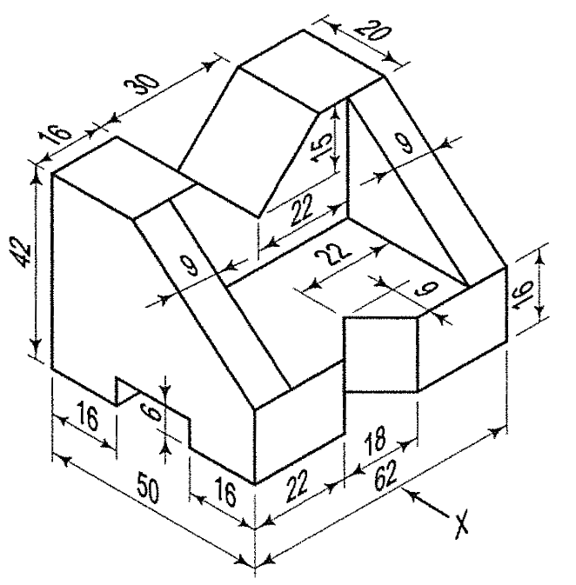 | L4 | CO6 | [8M]
 |  | OR
 | b) | Draw the Front view Top view and side view for the following figure.  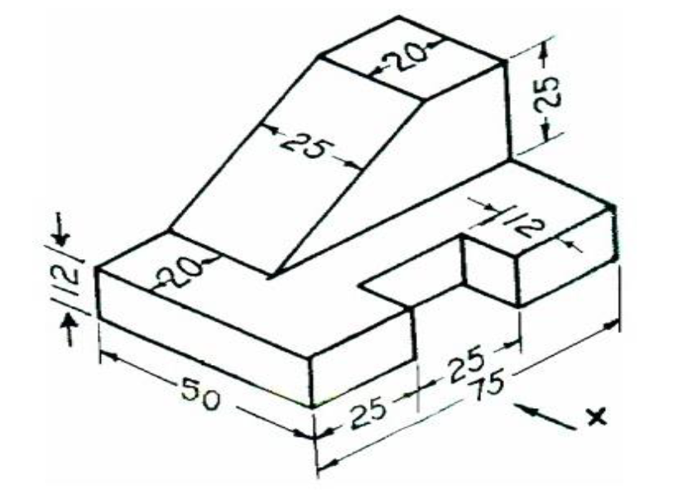 | L4 | CO6 | [8M]

-- 00 -- 00 –

